Zero de Conduite (Zero for Conduct, 1933)
Thomas Patrick Pringle (McGill University)
Directed by Jean Vigo, Zero for Conduct is a short film about young boarding school students rebelling against their teachers’ strictures. The film is an autobiographical take on Vigo’s youth and an homage to the spirit of his infamous anarchist father, Miguel Almereyda. Accordingly, Zero for Conduct was initially banned for its lawless attitude, and was only released in 1945, more than a decade after Vigo’s early death. The film is known for its impish charm and effervescent style; it blends a scathing criticism of the harsh conditions of French boarding schools with an anti-authoritarian anarchist politics, presented through the children’s eyes. Gentle surreal touches recur throughout the film: the diminutive size of the head lecturer, a pillow fight that concludes with a procession in slow motion, and the fruit-pelting of the school’s authorities, caught by surprise by a group of ambushed children. This was Vigo’s third film, and, with L’Atalante, one of only two features. Zero for Conduct is a complex work in its refusal to be defined by realism, fiction, or the fantastic. The film’s influence has been profound, finding tribute in François Truffaut’s The 400 Blows (1959) and Lindsay Anderson’s if… (1968).
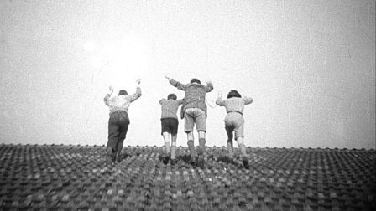
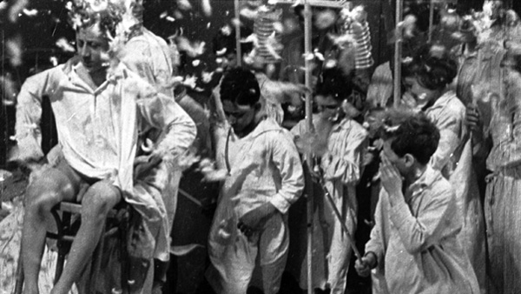
Image source: http://www.criterion.com/films/27757-zero-de-conduite
Pillow Fight:
http://www.youtube.com/watch?v=Ke3PQVK87mc
Interview on the Pillow Fight:
http://www.youtube.com/watch?v=ZluNgJA1MNg
References and Further Reading
Gomes, Paulo. (1971) Jean Vigo. London: Secker & Warburg.
Smith, John. (1972) Jean Vigo. New York: Praeger.
Temple, Michael. (2005) Jean Vigo. New York: Manchester UP.

